**Network Access**

Access to the service desk requires a valid login. A successful login will consist of username and password. An example of correct username would be:

[Flastname123@iwcc.edu](mailto:Flastname123@iwcc.edu)

The link to access the technician page is <http://pcsupport.ecc.iwcc.edu/scp/>

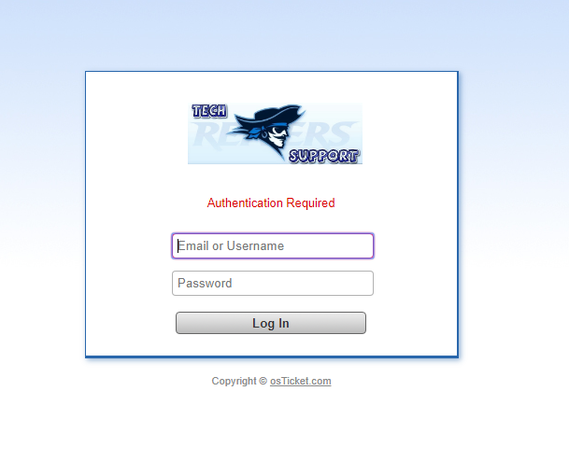

Iowa Western uses a WLAN network. Students get access to the internet by connecting to a wireless access point using their username and set password. Students are able to access the service desk site outside of campus.

**Layout**

